**Entity Relationship Diagram – ER Diagram in DBMS**

An **Entity–relationship model (ER model)** describes the structure of a database with the help of a diagram, which is known as **Entity Relationship Diagram (ER Diagram)**. An ER model is a design or blueprint of a database that can later be implemented as a database. The main components of E-R model are: entity set and relationship set.

**What is an Entity Relationship Diagram (ER Diagram)?**

An ER diagram shows the relationship among entity sets. An entity set is a group of similar entities and these entities can have attributes. In terms of DBMS, an entity is a table or attribute of a table in database, so by showing relationship among tables and their attributes, ER diagram shows the complete logical structure of a database. Lets have a look at a simple ER diagram to understand this concept.

**A simple ER Diagram:**

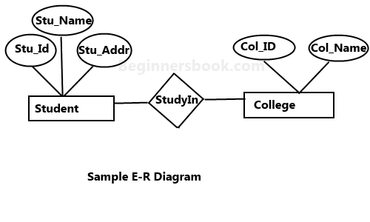

In the following diagram we have two entities Student and College and their relationship. The relationship between Student and College is many to one as a college can have many students however a student cannot study in multiple colleges at the same time. Student entity has attributes such as Stu_Id, Stu_Name & Stu_Addr and College entity has attributes such as Col_ID & Col_Name.

Here are the geometric shapes and their meaning in an E-R Diagram. We will discuss these terms in detail in the next section(Components of a ER Diagram) of this guide so don’t worry too much about these terms now, just go through them once.

**Rectangle**: Represents Entity sets.  
**Ellipses**: Attributes  
**Diamonds**: Relationship Set  
**Lines**: They link attributes to Entity Sets and Entity sets to Relationship Set  
**Double Ellipses:** Multivalued Attributes  
**Dashed Ellipses**: Derived Attributes  
**Double Rectangles**: Weak Entity Sets  
**Double Lines**: Total participation of an entity in a relationship set

**Components of a ER Diagram**

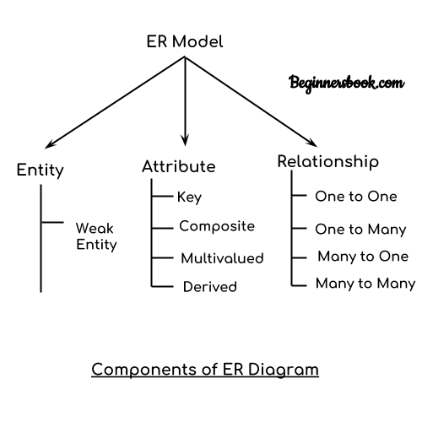

As shown in the above diagram, an ER diagram has three main components:  
1. Entity  
2. Attribute  
3. Relationship

**1. Entity**

An entity is an object or component of data. An entity is represented as rectangle in an ER diagram.  
For example: In the following ER diagram we have two entities Student and College and these two entities have many to one relationship as many students study in a single college. We will read more about relationships later, for now focus on entities.

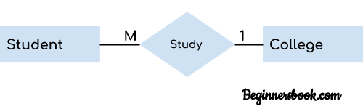

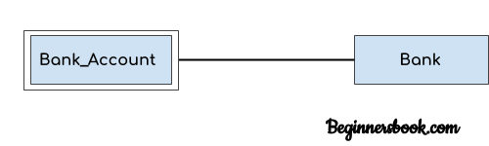

**Weak Entity:**  
An entity that cannot be uniquely identified by its own attributes and relies on the relationship with other entity is called weak entity. The weak entity is represented by a double rectangle. For example – a bank account cannot be uniquely identified without knowing the bank to which the account belongs, so bank account is a weak entity.

**2. Attribute**

An attribute describes the property of an entity. An attribute is represented as Oval in an ER diagram. There are four types of attributes:

1. Key attribute  
2. Composite attribute  
3. Multivalued attribute  
4. Derived attribute

**1. Key attribute:**

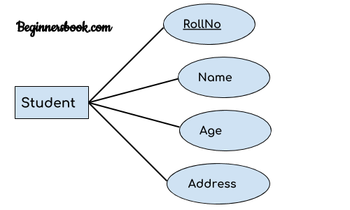

A key attribute can uniquely identify an entity from an entity set. For example, student roll number can uniquely identify a student from a set of students. Key attribute is represented by oval same as other attributes however the **text of key attribute is underlined**.

**2. Composite attribute:**

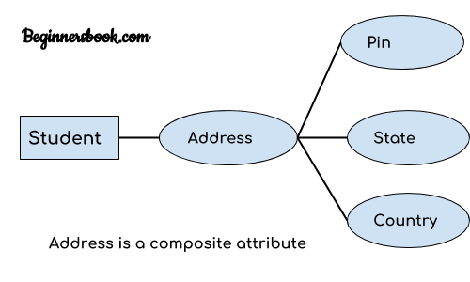

An attribute that is a combination of other attributes is known as composite attribute. For example, In student entity, the student address is a composite attribute as an address is composed of other attributes such as pin code, state, country.

**3. Multivalued attribute:**

An attribute that can hold multiple values is known as multivalued attribute. It is represented with **double ovals** in an ER Diagram. For example – A person can have more than one phone numbers so the phone number attribute is multivalued.

**4. Derived attribute:**

A derived attribute is one whose value is dynamic and derived from another attribute. It is represented by **dashed oval** in an ER Diagram. For example – Person age is a derived attribute as it changes over time and can be derived from another attribute (Date of birth).

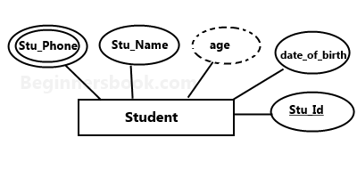

**E-R diagram with multivalued and derived attributes**:

**3. Relationship**

A relationship is represented by diamond shape in ER diagram, it shows the relationship among entities. There are four types of relationships:  
1. One to One  
2. One to Many  
3. Many to One  
4. Many to Many

**1. One to One Relationship**

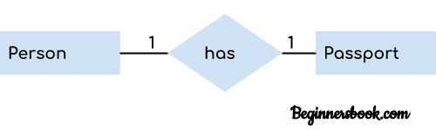

When a single instance of an entity is associated with a single instance of another entity then it is called one to one relationship. For example, a person has only one passport and a passport is given to one person.

**2. One to Many Relationship**

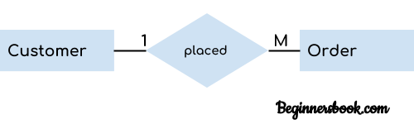

When a single instance of an entity is associated with more than one instances of another entity then it is called one to many relationship. For example – a customer can place many orders but a order cannot be placed by many customers.

**3. Many to One Relationship**

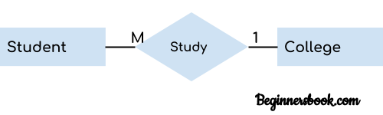

When more than one instances of an entity is associated with a single instance of another entity then it is called many to one relationship. For example – many students can study in a single college but a student cannot study in many colleges at the same time.

**4. Many to Many Relationship**

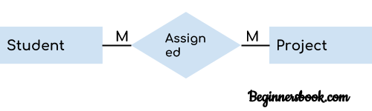

When more than one instances of an entity is associated with more than one instances of another entity then it is called many to many relationship. For example, a can be assigned to many projects and a project can be assigned to many students.

**Total Participation of an Entity set**

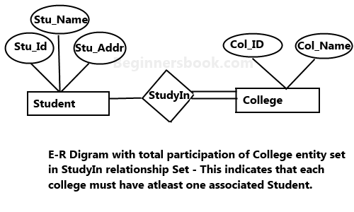

A Total participation of an entity set represents that each entity in entity set must have at least one relationship in a relationship set. For example: In the below diagram each college must have at-least one associated Student.